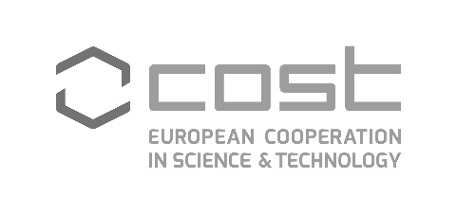
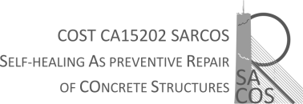

HOST APPROVAL OF THE SCIENTIFIC REPORT
Data

This letter is to confirm that __________Name of STSM applicant______________from ________________Institution name, City, County__________________________ has successfully completed her Short Term Scientific Mission at __________Name of the host institution, City, Country_________ in the period from ____ to ______in the frame of the COST Action CA15202 (SARCOS).
During her stay she worked on the ___________________________________________________

HOST

