Venue: The course will take place in two city locations: Skopje and Ohrid. Skopje is the capital and the largest city in Macedonia. Located at the upper course of Vardar River, on the main North - South Balkan route (Corridor 10), it is the country' political, economic and academic centre. Ohrid, ancient name Lychnidos (the City of Light), is a true living pearl, one of the oldest and most remarkably well-preserved historic sites in Europe. This place, where Cyrillic Alphabet was invented, is also called "The Balkan Jerusalem", with 365 churches and two recognized saints who lived and died there: St. Kliment of Ohrid (840 - 916 AD) and St. Naum of Ohrid (830 - 910 AD). Since 1979 Lake Ohrid is under UNESCO protection as part of the World Natural Heritage; in 1980 Old Town has been also put on the UNESCO list as a part of the World Cultural Heritage. In other words, Ohrid is one of only 28 spots in the World where both nature and culture are protected by the UNESCO. Also, the most attractive gypsum deposit located on the western part of the country will be visited on a professional tour.
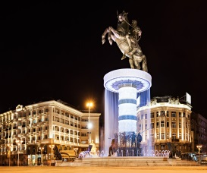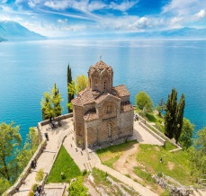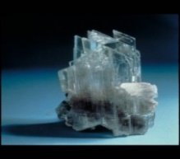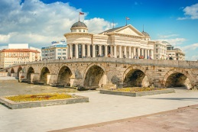
SARCOS COST-RILEM Doctoral Course: Faculty of Technology and Metallurgy in the frame of ”Ss Cyril and Methodius” University in Skopje is hosting this doctoral course in cooperation with the Institute of Earthquake Engineering and Engineering Seismology (IZIIS), Institute for Inspection of Building Materials and Development of New Technologies (ZIM "Skopje" AD Skopje), Cementarnica USJE AD Skopje – TITAN Group and KNAUF-Radika. The planning of the course is done in cooperation with Technion - Israel Institute of Technology, Faculty of Civil & Environmental Engineering and Technical University of Denmark.
Financial support: The doctoral course will be financed by COST (European Cooperation in Science & Technology), Action: CA15202 – Self-healing As preventive Repair of Concrete Structures.
Scientific Support by RILEM: RILEM is the international union of experts in construction materials, systems and structures with the aim to promote scientific cooperation. RILEM is scientific sponsor for the doctoral course. All doctoral students registered in the full doctoral courses are offered a three year RILEM membership. More info about RILEM can be found at: www.rilem.net.
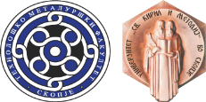 Faculty of Technology and Metallurgy, ”Ss. Cyril and Methodius” University in Skopje

SARCOS COST - RILEM
Doctoral Course

Advanced materials and technologies based on inorganic binders

Skopje, 2-5 Sept. 2018 &
Ohrid 6-7 Sept. 2018

Lecturers: Konstantin Kovler; Ole Mejlhede Jensen; Nele De Belie; Liberato Ferrara; Jonjaua Ranogajec; Alva Peled; Henk Jonkers; Veronika Shendova; Emilija Fidanchevski

Organized by: Konstantin Kovler; Ole Mejlhede Jensen; Nele De Belie; Emilija Fidanchevski

Sponsored by: SARCOS COST Action CA15202, RILEM, Cementarnica USJE AD Skopje – TITAN Group, KNAUF-Radika, ZIM "Skopje" AD Skopje, IZIIS
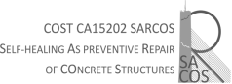 | 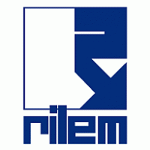 | 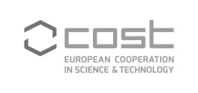
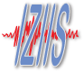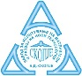
Scope of Course:
The course enriches the participants with up-to-date knowledge on advanced materials and technologies related to inorganic binders. Self-healing of materials, role of nanomaterials, modern uses of composites, sustainability and safety requirements for the use of inorganic materials in construction, and other topics are addressed. The students will share their recent research results and participate in the laboratory works.
Course Content and Schedule:
The course consists of lectures, laboratory works and a professional tour. The planned social activities are aimed to stimulate a friendly study atmosphere.

The following topics will be presented during the course:
- Inorganic binders: historical development, manufacture, composition and properties
- Supplementary cementitious materials
- Self-healing of lime mortars
- Autogenous self–healing of historical binders
- The state of water in inorganic binders - Powers’ model
- Self-healing of cementitious materials
- Nanofillers in cement based composites
- Gypsum and its uses in construction
- Control of water in inorganic binders and superabsorbent polymers
- Development, application and valorization of bacteria-based self-healing concrete
- Engineering Cementitious Composites
- High Performance Fibre Reinforced Cementitious Composites
- Advanced composites in earthquake engineering
- Nanomaterials in construction

Work Load and Study Material:
Each course participant is requested to bring and present a poster describing their own research topic.

The whole work load of the course includes: preparatory work before the course, participation in the whole course finalized with an evaluation of learning outcomes through an oral presentation in plenum, poster preparation and personal presentation. The total workload of approximately 140 hours corresponds to 5 ECTS.

Certificates:
Certificates will be issued based on active participation in the entire course.

Participants:
The participants are expected to have a basic knowledge of inorganic construction materials like: gypsum, lime, concrete. Level and form of the course is aimed at doctoral students, but both final year master student and practicing engineers can also benefit from course participation. English will be the official language of the course.

Costs:
A course fee of 250 EUR will apply for entire course, and the fee for single day participation will be 80 EUR per day. The student will be responsible for their own travel, accommodation and insurance. Meals (five lunches and two dinners) according to the program will be free of charge.

Financial Support – Grants:
The SARCOS COST Action will offer around 30 fixed grants (amount still to be confirmed) to trainees coming from COST and Near Neighbour Countries. These grants are a contribution to travel, accommodation and meals expenses of trainees during their attendance to the course, but they will not necessarily cover the totality of the expenses. COST granted student will not be charged for the course fee. Only participants attending the entire course (6 days) are eligible for a grant. The grants will be given in a first come first served basis, after checking that the eligibility criteria and reasonable country balance are met.

Further Information and Registration:
Further information on available grants and contacts can be found in the homepage of the COST Action CA15202: https://www.sarcos.eng.cam.ac.uk/activities/trainingschools.

