Abstract title

Author’s name
Affiliation, Address
E-mail contact: name@organisation.org

OBJECTIVES
The author should briefly present his/her PhD/ECI’s ongoing research on self-healing of concrete structures. An intention is to show the results but also to highlight “How should the self-healing/repair topic improve during the next years to ensure their success?” The author should clearly state the issues in his/her research which are still to be developed. This will open the discussion as a round table where possibly he/she would find a solution how to overcome a certain scientific problem. This could initiate possible future collaborations between PhD students and ECI researchers within the members of SARCOS COST Action.

INSTRUCTIONS

The document must be in Word format (*.doc or *.docx file) and shall not exceed 2 pages. Use the standard DIN A4 paper size (210 x 297 mm) and the margins as follows:

• Top: 3.6 cm
• Bottom: 3.6 cm
• Left: 2.5 cm
• Right: 2.5 cm

The font of the body text is Calibri, size 11 pt unless another size is specifically mentioned in these guidelines. In general, all text is single spaced and justified both left and right. The header and the footer of this page must appear on all pages. There should not be any other footer. Do not use automatic cross references and footnotes. Do not insert page numbers in the manuscript as this will be added afterwards during the editorial process.
If there is a need to present a figure or a table, please place them centered in the middle as it is shown in the following examples:

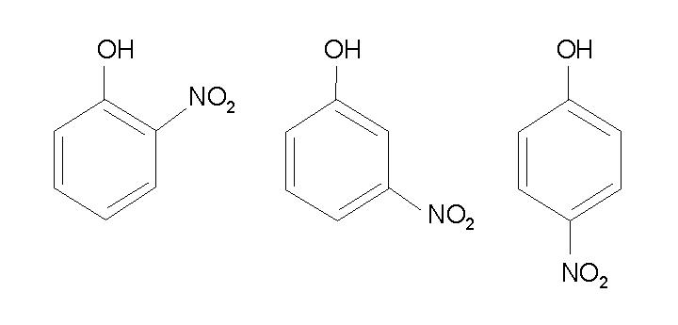
Figure 1: Description of Figure 1. (optional)

Table 1: Description of table 1 (optional)

REFERENCES
In the text, references to literature should be made in square brackets [xx], where xx refers to the relevant number in the reference list. The references should be numbered in the order of appearance as it is shown below.
[1] Author AB, Author CD, Author EF. Title of article. Journal Title 22 (2018) p. 11-25
[2] Author AB, Author CD. Title of book. 1998.Publisher. City, Country.
[3] Author AB. Title. 2014.http://www.address.com. Accessed Day Month Year.

ACKNOWLEDGEMENT

The author acknowledge the support from EU COST Action CA 15202 “SARCOS” (http://www.sarcos.enq.cam.ac.uk). The author would also like to thank…

HOW TO APPLY
- Abstract of the PhD/ECI research
- Short CV
- Letter of Recommendation by home institution
To be sent by e-mail to the addresses: heritagelab@tf.uns.ac.rs,
with CC to: Dr. M. Sánchez Moreno msmoreno@uco.es
Dr. M.J. Bayarri Clariana ghmanager.upv@gmail.com
DEADLINE
Deadline for applications December 21st 2018
Deadline for the evaluation of the applications January 15th 2019
CONTACT
Dr. Bojan Miljevic (miljevic@uns.ac.rs)
Dr. Marta Roig Flores (marta.roig@ietcc.csic.es)
Organization: Laboratory for Materials in Cultural Heritage (heritagelab@tf.uns.ac.rs)

