Abstract title

Author’s name
Affiliation, Address
E-mail contact: name@organisation.org

OBJECTIVES
The author should briefly present his/her PhD/ECI’s ongoing research on self-healing of concrete structures. The aim is to present results and to discuss on the challenges of self-healing/repair concrete, focusing on durability of the structure and the material. The author is also invited to point out the issues in his/her research that will be developed during the next years. This will open the talks during the discussion and round table sessions and could initiate possible future collaborations between PhD students and ECI researchers of the SARCOS COST Action.

INSTRUCTIONS

The document must be in Word format (*.doc or *.docx file) and shall not exceed 2 pages. Use the standard DIN A4 paper size (210×297 mm) and the margins as follows:

• Top: 2.5 cm
• Bottom: 2.5 cm
• Left: 3.0 cm
• Right: 3.0 cm

The font of the body text is Calibri, size 11 pt unless another size is specifically mentioned in these guidelines. In general, all text is single spaced and justified both left and right. The header and the footer of this page must appear on all pages. There should not be any other footer. Do not use automatic cross references and footnotes. Do not insert page numbers in the manuscript as this will be added afterwards during the editorial process.
If there is a need to present a figure or a table, please place them centred in the middle as it is shown in the following examples:
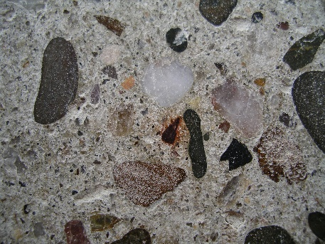
Figure 1: Description of Figure 1. (optional)

Table 1: Description of table 1 (optional)

REFERENCES
In the text, references to literature should be made in square brackets [xx], where xx refers to the relevant number in the reference list. The references should be numbered in the order of appearance as it is shown below.
[1] Author AB, Author CD, Author EF. Title of article. Journal Title 22 (2018) p. 11-25
[2] Author AB, Author CD. Title of book. 1998.Publisher. City, Country.
[3] Author AB. Title. 2014.http://www.address.com. Accessed Day Month Year.

ACKNOWLEDGEMENTS (optional)
The author would like to thank…

HOW TO APPLY
- Abstract of the PhD/ECI research
- Short CV
- Letter of Recommendation by home institution
To be sent by e-mail to: eduardo.pereira@civil.uminho.pt and marroifl@cam.upv.es
DEADLINE
Deadline for applications | January 10th
CONTACT
Dr. Eduardo Pereira (eduardo.pereira@civil.uminho.pt)
Dr. Marta Roig Flores (marroifl@cam.upv.es)

