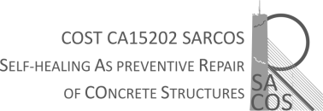

LETTER OF SUPPORT FROM THE HOME INSTITUTION

To the Grant Holder of the COST Action 15202

(City, date)

Hereby we conform to support the visit of Mr./Ms./Dr. (name of applicant), from (Home institution) for developing a short-term scientific mission (STSM) at (Host institution) from (initial date) onwards, with the total duration of (number) days, within the framework of the SARCOS COST Action (CA 15202).

The work plan supporting the STSM is described in the application. This STSM will have a mutual benefit for the applicant, and both for the home and host institution. The planned activities will contribute to strengthen the cooperation between the Home and Host institutions.

Applicant’s supervisor in Home Institution signature

(Name and surname of the applicant’s supervisor)

