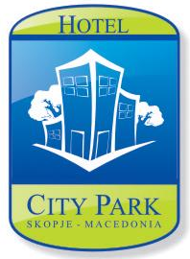

OFFER FOR ACCOMODATION FOR:

HOTEL (name): | HOTEL “CITY PARK”
CITY: | SKOPJE
Address: | Str. Mihail Cokov 8
Hotel email: | contact@hotelcitypark.com.mk
Reservation desk email: | contact@hotelcitypark.com.mk
Contact person for accommodation and email: | Kristina,Filip | Dragan ,Gojko
Contact person for conference requirements and email: | Kristina, Filip | Dragan, Gojko
Fax number: | +389 2 226 455
Phone number: | +389 2 3290 860
Prepared by: | Kristina Veljanova
Title: | Receptionist
Date: | 01.06.2018
Offer validation: | 02-05.09.2018

ACCOMODATION

Room type | Regular price (EUR) | (*) Discounted price (EUR)for 02-05.09.2018
Single Standard | 75 | 60
Single Comfort | 85 | 70
Single Suite | 95 | 80

We are working with the following credit card:

CREDIT CARDS | YES | NO
VISA | Yes
MASTERCARD | Yes
AMEX | Yes
DINERS | Yes
MAESTRO | Yes

Every reservation must be guaranteed with a credit card number. No deposit will be charged.

Room cancelation policy is:

(16:00)- 48 hours before the day of arrival

SERVICES | Yes/No | Price ( EUR) | % Discount
Airport transfers | Yes | 15 | /
Breakfast | Yes | Incl.
Local telephone calls charges waived | Yes
Internet access | Yes | Incl.
Parking | Yes | Incl. | Reservation needed
Laundry | Yes
Telephone | Yes
Restaurant | Only for Breakfast and Conference events

For more information please visit our web site:
www.hotelcitypark.com.mk

