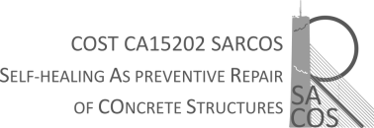

HOST APPROVAL OF THE SCIENTIFIC REPORT
Date

This letter is to confirm that __________Name of STSM applicant______________from ________________Institution name, City, Country__________________________ has successfully completed his/her Short Term Scientific Mission at __________Name of the host institution, City, Country_________ in the period from ____ to ______in the frame of the COST Action CA15202 (SARCOS).
During the stay he/she worked on ___________________________________________________

HOST

