DTU ,,Pine Holidejs,,
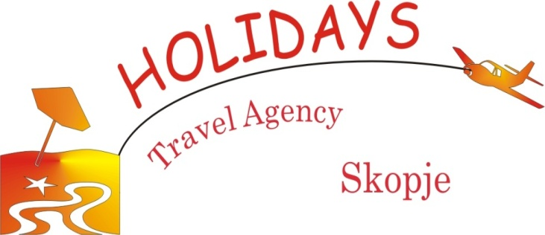
Travel Agency ,,Holidays,, Licence А
Str. Mile Pop Jordanov No.1b
www.macedoniaholiday.mk
E-mail: holidaycompa@gmail.com
Tel: + 389 2 30 60 041
Mob: + 389 70 29 59 86

OFFER
FOR ACCOMODATION IN SKOPJE during the
SARCOS Training School

1. Hostel URBAN (http://www.urbanhostel.com.mk)
- 4 or 6 dorm room----12 eu per person
- Private room for one person----22 eu
- Private room for two persons----33 eu
- Apartments
35 €(2 persons)
45 €(3 persons)
58 €(5 persons)

In the price are included bed, tourist tax and VAT as well.
2. Hotel Kozle (http://hotelkozle.mk)
Single room ---27 eu
Double room-----30 eu
Triple room------38 eu

Suppliment for breakfast 3 eu per person.
Breakfast is served at Hotel Pine.
In the price is included Tourist tax, VAT, free WI-FI.

3.Hotel Pine 3* - Skopje (www.hotelpine.com)
Single room ---27 eu
Double room-----30 eu
Triple room------38 eu
Apartament (3, 4 or 5 persons) -42 eu

Suppliment for breakfast 3 eu per person.
Gratis:
* water, tea, juice.
*after the breakfast transfer from Hotel Pine to the TMF

In the price is included Tourist tax, VAT, free WI-FI.

4. Accommodation in stuidos and appartaments 3*.

Single studio----26 eu
Double stuido---30 eu
Appartament ( for 3 people)----38 eu
Appartament ( for 4 people)----42 eu

In the price are included tourist tax, VAT, WI-FI.

5. Hotel Victoria 4* (https://hotelvictoria.com.mk)

Single room ---35 eu
Double room-----48 eu

In the price are included breakfast, tourist tax, VAT, WI-FI.

6. Hotel IBIS Skopje City Center 4* (http://ibis-city-center.skopje-hotels.com)

Single room ---52 eu
Double room-----57 eu

In the price are included breakfast, tourist tax, VAT, WI-FI.

7. Hotel TCC Grand Plaza 5*(http://tccgrandplaza.com)

Single room ---60 eu
Double room-----70 eu

In the price are included breakfast, tourist tax, VAT, WI-FI, SPA centar.

8. Transfer from/to Aerport Skopje/Hotel (one way):
Car (max 3 passengers) ------ 15 eu
Mini VAN (max 8 passengers)----35 eu

9. Transfer Ohrid-Aerodrom Skopje
Bus 50 seets----380 eu + 5% VAT.
Minibus 17 - 20 seets-----180 to 210 eu + 5% VAT.

10. Bout Ohrid-Sv.Naum-Ohrid-------10 eu
For a group bigger than 20 people-------9 eu

NOTE:
*All hotels are on request/ limited number of rooms.
*All hotels are at maximum 1 km from the TMF. Hotel Ibis Skopje City Center.
* The prices in this offer refer to reservations made through Travel Agency "Holidays" Licence A.

For all informations, please contact us on:
TEL: + 389 2 30 60 041
MOB: + 389 70 29 59 86
FAX: + 389 2 30 82 032

holidaycompa@gmail.com
www.macedoniaholiday.com
Str.Mile Pop Jordanov N.1b, Skopje,R.Macedonia

