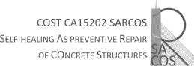
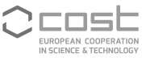

3rd SARCOS TRAINING SCHOOL
“Advanced solutions for the external repair of concrete”
Thessaloniki (Greece) 20th -22nd January, 2020

APPLICATION FORM

APPLICANT DETAILS

FIRST NAME:

SURNAME:

E-MAIL:

CITY:

COUNTRY:

DATE OF BIRTH (DD/MM/YYYY):

GENDER (M/F):

STUDENT OR ESR (PhD + 8 years) (Y/N):

INSTITUTION DETAILS

NAME OF INSTITUTION & GROUP OF RESEARCH / COMPANY:

CITY:

COUNTRY:

Date and signature:

