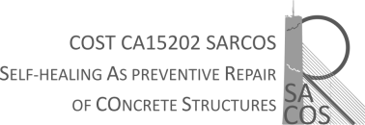

City, date

To the Grant Holder of the SARCOS (CA 15202) COST Action:

As a STSM applicant, I fully accept the consequences of the potential problems I may face at the moments of travelling in order to perform my stay or return home after having finished it, due to the global COVID-19 situation.

Signed: Name and surname of the applicant

